**Database Systems**

**Semester Project**

**Project Name: “**Freelancing Management System”

**Group Members:**

* **Shahmeer Tanveer ( 242821 )**
* **Syed Sarim Raza ( 242704 )**

**Task 1: Define Your Purpose and Audience**

**Purpose:**

The goal of this project is to create a database system that helps manage freelance work. Freelancers often work with several clients at the same time, and it can be difficult to keep track of tasks, deadlines, and payments. This system is designed to make that process easier and more organized.

It will allow users to store important information such as client details, project timelines, task progress, and invoice records. This helps freelancers stay on schedule, avoid missed deadlines, and keep track of their income and work history.

**Audience:**

* Freelancers who need a system to organize their projects and clients.
* Small business owners who work on client-based projects.
* Employers or recruiters reviewing student or candidate project work.
* Teachers or classmates reviewing the database design for feedback or grading.

**Task 2: Sketch Your Database Layout**

**Create ERD of your database**

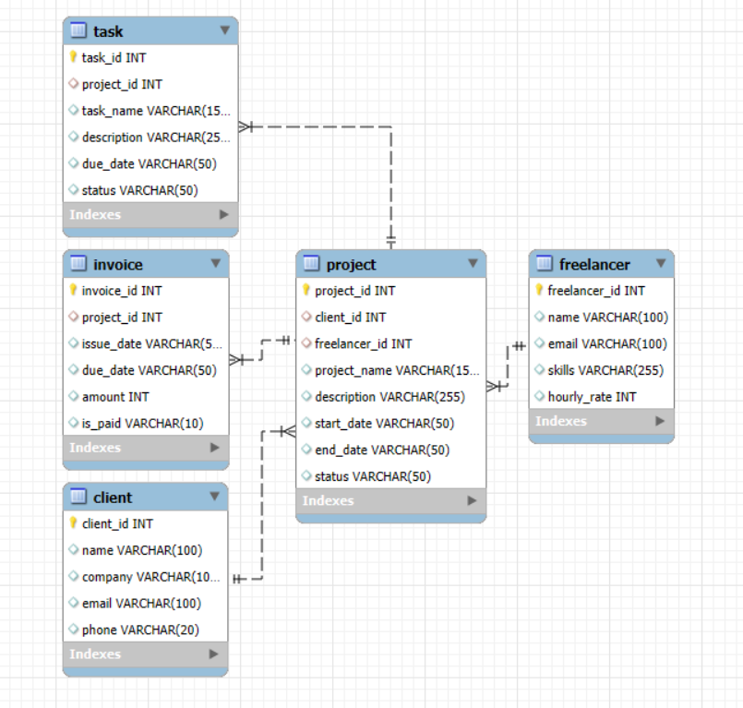

**Relationships:**

* One freelancer can have many projects.
* One client can be linked to many projects.
* Each project includes multiple tasks.
* A project can also have one or more invoices.